+November 2007
- Installed vertical single block heat exchanger.
- Klean Corp flushed Coldbox and new heat exchanger.
March 2008
- Installed auto drain back valves.
April 2008 Run/Outage
- BOS filter failure.
- Replaced BOS with new style.
- Replaced carbon.
- Replaced coalescer filters.
- Replaced after filter.
November 2008 Run
- First shaft seal leakage.
- Had to add a lot of oil during run.
January 2009 Outage
- Shaft seal replaced.
February 2009
- Second shaft seal leakage.
Summer 2009 Outage
- CMS warm-up on July 13.
- Shaft seal replacement.
- Instrument Air isolation on Coldbox and HX Module.
- Replaced P-6300.
- Added 6 gallons oil to compressor.
- Slide valve repaired (EVA). Screw rod end on slide valve broke tip.
- Replaced diodes TI-6103/6203/6303.
- CMS cooldown on September 6.
September 6, 2009 Run
- Ice ball formed on 6300 diode tower.
- TI-6202 reading high (~3K). 6200 loop placed in Pressure Control Mode.
- TI-6203 reading UNSAT.
- System adjustments made during run due to system degradation.
- Third shaft seal leakage.
October 25th Turn-around
- CMS warm-up on October 25th.
- Replaced diodes TI-6202/6203.
- CMS cooldown on October 27th.
October 27th Run
- Ice forming on 6300 diode tower.
- System adjustments made during run due to system degradation.
- Flame detectors tested.
- Warm up 12/23/09.
Outage
- He Comp UPS failure.
- Power lost to Bldg 8760.
- The He Compressor is in operation with the Chilled Water Inlet valve closed to allow heating of the system helium. The system flow is directed through the adsorber for further warm-up. The RGA is connected to the outlet of the adsorber for analysis. Test cut short due to Tower Water issues.
- Added 4 gallons oil to compressor.
- Deriming of Coldbox from January 5th to January 26th.
- VJ lines pumped down.
- Diode TI-6510/6507 replaced.
- Diode TE-6510 replaced. The cable running from the junction box to TE-6510 was also replaced due to damage to the Amphenol connector that was found while troubleshooting TE-6510.
- Shaft seal replaced.
February 2010 Run
- Cool down 2/11/10.
- Diode TI-6510 OOS.
- New Watlow heater.
- Warm up 2/12/10.
- Diode TI-6510 replaced.
- Cool down 2/13/10.
- Warm up 2/14/10.
- Diode TI-6507 replaced.
- Cool down 2/17/10.
- PI-6010 (He to H2 HX’s Module) replaced.
- Warm up 2/28/10. Completed Stop and go testing data will be analyzed to determine path forward.
March 2010 Run
- Cool down 3/3/10.
- CMS initiated an MPS trip due to low H2 flow on loops 6100 and 6200. The Control Room Shift Supervisor also stated that he had received an alarm for PLC-8922. Upon investigation by operations it was discovered that the HX temperatures for loops 6100 and 6200 were fluctuating from -3k to 10k which in turn caused the low flow alarm since the flow elements are temperature compensated from these temperature indicators. We investigated the CMS H2 diode cabinet and found that the card chassis for all the "A" channel diodes had failed. We unplugged the diodes from the "A" chassis and plugged into the "B" chassis which restored proper temperature readings which in turn restored proper flow indications. High power beam is back on target and the loops are controlling normally. The ERM's will investigate the chassis failure in the morning. 3/3/10.
- The power supply for the Lakeshore chassis for the Channel A diodes has been changed out. The indications are SAT. 3/4/10.
- Received an MPS trip from PI-6201 on low loop pressure as a result of a beam trip due to EKick07 tripping the MPS. Loop pressure dropped to ~173.1 psig during this transient. I also received a minor low pressure alarm on Loop 6100 (lowest pressure on loop was ~174.5 psig. All pressure in both loops recovered and alarms cleared within 5 minutes. 3/6/10.
- Received a couple of MPS trips this morning following beam shutdowns for SCL 15 and SCL 18 modulator faults. The SME has been tuning the HX loop TCV's in an attempt to lessen these pressure drops when beam is lost. Trends on the loop circulator suction pressures are attached to show system response to the latest beam trips to assist in valve tuning. 3/7/10.
- Warm up 3/20/10.
Outage
- Single stage HX change out performed to upgrade to a dual stage HX set-up.
- HRS purge/backfill cycles performed using coldtraps.
March 2010 Run
- Cool down 3/24/10.
- System adjustments were made due to system degradation.
- Warm up 4/6/10.
- During warm-up, PCV-6204 was not operating correctly. In order to vent the rising H2 pressure in the 6200 loop, the associated Dump Valves was opened. This resulted in RD-6201 failing. RD-6201 was replaced.
- Warm-up valves PCV-6104/6204 rebuilt and tested SAT.
- Flowed heated N2 through the charcoal bed.
- Cool down on 4/8/10.
- System adjustments were made due to system degradation.
- Warm up 4/17/10.
Outage
- Carbon replaced and added Mole Sieve to top portion.
- Drained the After-cooler and Oil Cooler to leak check. Leak check SAT.
- Derimed coldbox.
- TV-6510 was removed from the system and piping was capped off. All electrical connections to the valve are still intact.
April 2010 Run
- Cool down 4/21/10.
- System adjustments were made due to system degradation.
- Warm up 5/15/10.
- Flowed heated N2 through charcoal bed.
- Tie-in of KF-45 fitting to Adsorber.
- Derimed coldbox.
- Cool down 5/19/10.
- System adjustments were made due to system degradation.
- Warm up 6/30/10.
Outage
- Derimed coldbox.
- Circulators 6100/6200 replaced.
- Swapped over to Tower Water to the After-cooler.
- Compressor shaft seal and EVA replacement.
- Installed Purification System.
- HRS test run 8/13/10.
August 2010 Run
- Cool down started on 8/16/10. Developed cold leak on the defrost header due to solenoid valve not properly seating. Warmed system back up to get valves to reseat. Cooled down to 100K to test solenoid valves (tested SAT).
- Cool down on 8/17/10.
- System adjustments were made due to system degradation.
- Linde system online to the HPH with only local readings 8/23/10.
- During run, Linde readings taken showed high OilAero readings (32 to 322 ppm). This was due to drain valve installment wrong.
- Warm up 8/29/10.
Outage
- Derimed coldbox.
- BOS filters changed with correct filters.
- Coalescer filters changed.
- After filter changed.
- Carbon replaced.
- Automatic drain valves removed.
- Shaft seal replaced.
- Replaced EVA.
- Chilled Water back to the After-cooler.
- Drained oil from compressor and replaced with new oil.
- Purification run.
September 2010 Run
- Cool down on 9/3/10.
- Purifier lined up to Buffer Tank.
- Linde readings taken was within normal range.
- Showing slight degradation.
- Linde system has been online since September 3rd (except for September 21st to 24th). Indications are showing only very slight fluctuations.
- Warm up 12/22/10.
Outage
- Linde tied into PLC and EPICs 12/27/10.
- Purifier isolated 12/29/10.
- TV-6510 reinstalled.
- YV-6540/6546 replaced.
- YV-6537/6549 replaced.
- Circulator 6300 replaced.
- H2 Cabinet H2 Sensors calibrated.
- Flame detectors annual check performed.
- Added 5 gallons of oil.
- Purification run.
February 2011 Run
- Cool down 2/9/11.
- Purifier lined up to Buffer Tank.
- Warm up 3/12/11.
- RD-6104/6204/6304 replaced.
- Added 1 gallon of oil.
March 2011 Run
- Cool down 3/15/11.
- Warm up 4/3/11.
- Purifier level controller not working. Secured purifier 4/17/11.
- Purifier level controller working properly after testing. Purifier restarted 4/17/11.
April 2011 Run
- Cool down 4/19/11.
- Purifier online.
- Minor TIC down.
- Warm up 6/30/11.
- Purifier secured.
Outage
- HV-6516 (Adsorber vent valve) replaced.
- Tower Water back to After Cooler.
- SV-6540 leak repaired.
- PCV-6103 rebuilt.
- RD-6003 replaced.
- Diode TI-6102 replaced.
- Flame Detector AT-6004 replaced.
- Purification run.
August 2011 Run
- Cool down 8/2/11.
- Purifier online to the Buffer Tank.
- EVA failed (faulty analog output card was bad, replaced). Operation of CMS ongoing. Helium Gas Panel also shows Major PLC Fault.
- H2 Loop 1 temp controller adjusted.
- TIC-6502 lowered.
- Diode TI-6301 failed.
- Pressure Control Mode tested 12/20/11.
- Warm up 12/22/11.
- Purifier secured.
Outage
- Circulators 6100/6200/6300 replaced.
- Carbon drying.
- RD-6105/6101/6205 RD-1 replaced.
- Diode TI-6301 replaced.
- Purification run.
February 2012 Run
- Cool down 2/6/12.
- Purifier online.
- TIC-6502 lowered.
- H2 Loop 1 PIC adjusted.
- FCV PID controls adjusted to slow the response time.
- The PID controls for PV-6532 (Coldbox bypass valve) was adjusted to speed the valve actuation up. The gain was increased from 35 to 40 and the integral was increased from 5 to 10.
- The coldbox bypass valve, PV-6522, has been sped up by increasing the gain from 40 to 43.
Loops 2 and 3 flow control valves, FCV-6203/6303, have been decreased on the gain from 45 to 43.
- Heater watts erratic.
- Warm up 6/21/12.
- Purifier isolated.
Outage
- F-6501 replaced.
- PCV-6104 rebuilt.
- Purification run.
- Purifier secured.
- The PMV controllers for PCV-6204 and PCV-6304 have been replaced and the instument air has been re-tubed and connected.
- Circulator 6100 replaced.
- Test run for heater controls with purifier online SAT. Purification run.
- Purifier secured.
- H2 sensors in HUR exhaust tested.
- A Rosemont pressure transmitter has been mounted and wired to read the PI-6404 compressor discharge pressure indication.
August 2012 Run
- Cool down 8/13/12.
- Purifier online.
- Warm up 11/5/12.
- Purifier secured.
Outage
- After filter replaced
- Carbon replaced.
- Coalescer filters replaced.
- BOS inspected.
- Purification run.
November 2012 Run
- Cool down 11/15/12.
- Warm up 12/21/12.
Outage
- Helium purification run.
January 2013 Run
- Cool down 1/4/13.
- Secured Purifier to troubleshoot N2 leak 1/7/13.
- Purifier back in service after VJ line clamp repair 1/29/13.
- Warm up 5/31/12.
- Purifier secured.
Outage
- F-6501 replaced.
- 6200 and 6300 circulator replaced.
- BOS replaced.
- Carbon replaced.
- After filter replaced.
- Helium purification run.
- Added 3 gallons of oil to compressor.
- Another helium purification run.
July 2013 Run
- Purifier online.
- Cool down 7/29/13.
- DPIC-6523 adjusted.
- TIC-6502 adjusted.
- PICs adjusted.
- Warm up 10/1/13.
Outage
- Purification run.
October 2013 Run
- Cool down 10/10/13.
- Adjusted TICs.
- Adjusted TIC.
- Estop was accidently hit and shutdown compressor. 12/23/13.
- Warm up 12/23/13.
Outage
- Purification run.
- Coalescers replaced.
- Carbon replaced.
- BOS replaced.
- Compressor shaft realigned.
- After filter replaced.
- F-6501 replaced.
- 6100 circulator replaced.
- HRS Test Run to check DP's across the system. Last production run the DP across F-6501 was 40-50PSIG, during this test run the DP was 0-4PSIG, we also have much less oil streaming through the ORS now with the improved BOS filters 1/25/14.
February 2014 Run
- Cool down 2/3/14.
- Purifier online.
- Secured the Helium Purifier due to a malfunction of the solenoid that controls the LN2 inlet valve. The valve will be replaced next week once the LN2 in the purifier boils off 5/9/14.
- Local readings indicate DT and DP only had slight rise.
- Warm up on 6/30/14.
Outage
- The boroscope inspection of the CMS Helium Compressor Bulk Oil Seperator was SAT. Inspection showed all visible gaskets, mounting rings, and filters was in installed position. There was only a slight oil sheen visible on the bottom where filters mount.
- The boroscope inspection on the CMS coldbox inlet filter F-6501 (Witches Hat) was SAT. Visual inspection showed the filter to be in near installed condition.
- H2 exhaust sensor calibration 7/16/14.
- 6200 and 6300 circulators replaced.
August 2014 Run
- Cool down on 8/5/14.
- Started the run with high DP on F-6501. Warmed up to replace, then cooled back down.
- Warm up on 8/11/14.
- Helium purification run.
- Shaft seal replaced.
- F-6501 replaced.
- Cool down 8/13/14.
- Local readings indicate DT and DP only had slight rise.
- Warm up on 9/30/14.
Outage
- Carbon replaced.
- Helium purification run.
- Coalescers inspected.
- F-6501 replaced.
- BOS replaced.
- After filter replaced.
October 2014 Run
- Cool down on 10/18/14.
- Started the run with a high DP on F-6501.
- Warm up on 11/3/14.
- Purifier secured.
Outage
- F-6501 replaced.
- RD-6201 replaced.
- After filter replaced.
- Helium purification run.
November 2014 Run
- Cool down 11/17/14.
- Started the run with a high DP on f-6501.
- Local readings indicate DT and other DP’s only had slight rise.
- Warm up on 12/26/14.
- Purifier secured 12/29/14.
January 2015 Run
- Cool down started. T-6501 tripped off when the system was coming out of the 100K hold. Received alarms on turbine bearing inlet and outlet gas pressures. Target Team Leader was called and it was decided to not attempt to cool down again until the System Engineer can have a look at the system this morning 1/9/15.
- When restarting, received low oil level alarm and subsequent shutdown of C-6401 while adjusting suction/discharge pressures. Preparations are underway to inspect bulk oil separator
- F-6501 replaced.
- BOS replaced.
- 4 gallons of oil added.
- Cool down on 1/12/15 for test run.
- Cool down on 1/14/15.
- Started the run with a high DP on F-6501.
- Had to add hydrogen to H2 Loop 3 due to PRV-6302.
- Turbine outlet diode failed on 3/1/15.
- Target CMS system has been evaluated after compressor trip due to lightning strike. Hydrogen system is holding and controlling pressure and all relief devices so no signs of leak through. Helium system: The compressor has been restarted and we have flow through the system. One relief valve on the cold box did lift during the event and we are trying to determine if it has re-seated. This has caused a loss of helium gas for make up so we are also determining if we have enough helium on site to re-start. Personnel are on there in to begin the change out of the hydrogen and helium cylinders. The turbine outlet temperature indication that has been OOS is going to have to be looked at to determine if we can cooldown in it current configuration and how it will affect the control system. It has an input to the turbine attenuator circuit and may affect turbine start condition and will also affect normal cold down indications so alternate method will have to be determined prior to cooldown. Controls personnel also on the way in to help with that indication. Estimated time to recovery is 12 hours from when we begin cooldown. Start of cooldown is not clear but a better estimate will be given as work progresses. 6/19/15.
- Cool down on 6/20/15.
- Local readings indicate DT and other DP’s only had slight rise.
- Warm up on 6/28/15.
Outage
- Diodes TI-6101/6202/6522 replaced.
- CMS MPS testing performed.
- H2 sensors in HUR exhaust tested and calibrated 6/9/15.
- H2 circulators (3) replaced.
- PRV-6302 replaced.
- Carbon replaced.
- BOS filters replaced.
- After filter replaced.
- Dual witch’s hat station initial test post install.
- F-6501 replaced.
- He Compressor oil changed.
August 2015 Run
- This run is first with dual witch’s hat station.
- Cool down 8/6/15.
- Warm up due to electrical power out to Target Bldg 8/18/15.
- Cool down 8/21/15.
- Witch’s hat replaced 9/8/15.
- Added hydrogen to H2 Loop 3 due to leak by of PRV-6302.
- Warm up 9/29/15.
- Local readings showed high DP on F-6501 and slight climb in DT.
Outage
- Carbon replaced.
- Shaft seal replaced.
- After filter replaced.
- PRV-6302 replaced.
- F-6501 replaced.
- Hand valve on Witch’s Hat Station replaced.
October 2015 Run
- Cool down 10/7/15.
- Warm up on 12/22/15.
- Local readings showed HPH DP and DT actually went down during run.
Outage
- Carbon replaced.
- After filter replaced.
- Dual witch’s hats replaced.
- RD-6104/6204/6304 replaced.
February 2016 Run
- Cool down on 2/1/16.
- Circulator current transducers rescaled.
- Warm up on 6/1/16.
- Local readings showed slight degrade over run.
Outage
- Carbon replaced.
- After filter replaced.
- BOS filters replaced.
- Shaft seal replaced.
- RD-6003 replaced.

July 2016 Run
- Cool down on 7/1/16 was secured due to actuation of PRV-6303 on H2 system.
- Lower witch’s hat filter replaced.
- Cool down on 7/6/16.
- Flame detector annual test verification performed 10/18/16.
- 12/22/16 H2 Loop 1 circulator speed increase test performed. The circulator speed for H2 Loop 1 has been increased from 155.0 to 180.0 Hz. The flow increased from 73.4 to 86.0 g/sec and bellow position increased from 60.4 to 62.0%. Slight increase in circulator discharge pressure was also observed. All parameters are now stable.
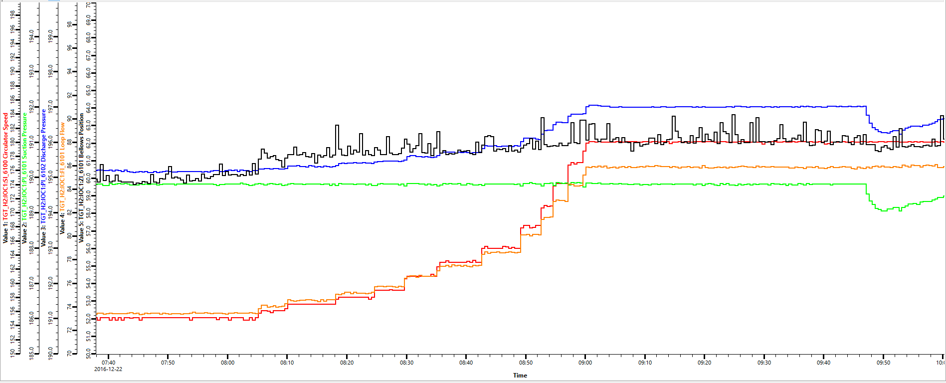
- 12/22/16 CMS warm up.
- 12/22/16 H2 and He Cabinets had panelview issues.
- Local readings showed degrade during run.
Outage
- 3 circulators replaced.
- H2 Cabinet-The OPI touch screen failed to boot. Replaced the OPI and returned the system to operation.
- He Cabinet-The vintage PLC I/O backplane failed and was replaced. The He GMS is returned to operation. 12/22/16.
- Rupture disks replaced. RD-6101 RD-6301 RD-6105 RD-6205 RD-6305.
- Dual witch’s hats have been replaced.
- Getter in H2 Loop 2 was replaced and then later removed due to un-operable.
February 2017 Run
- CMS cool down 2/22/17.
- Warm up on 5/27/17.
- Local readings showed degrade over run.
Outage
- Carbon replaced.
- H2 cabinet valve PGI-6619 replaced.
- The HPH was depressurized and borascoping of the vertical and ~2' of the horizontal run was performed to inspect the cleanliness of the line.
- Vacuum on the heat exchanger and coldbox vessel was broke with nitrogen. Borascoping of the interior heat exchanger vessel was performed to determine where super insulation was attached and determine piping configuration.
July 2017 Run
- Cool down on 7/6/17.
- Warm up on 10/2/17.
- Local readings showed degrade over run.
Outage
- Full flow purification for ~5 hours.
- H2 Gas Cabinet sensors replaced and calibrated.
- The Helium Gas Cabinet was found with an alarm in on PLC Major Fault Error. Issue was reported and troubleshooting was performed. The I/O module blocks were replaced and system is now back operational. 10/23/17.
October 2017 Run
- Cool down on 10/25/17.
- H2 Cabinet pressure switch on exhaust replaced 11/6/17.
- The CMS was recovered from power interruption that shutdown the helium compressor. The system is in Mode 5 Operation, normal operation. 11/8/17.
- Warm up on 12/20/17.
- Local readings showed degrade over run.
January 2018 Outage
- IRP change out. Transfer Lines tie in.
- He compressor motor changed out.
- H2 circulators replaced on all 3 loops.
- HUR Flame Detector annual maintenance and verification.
- Diode TI-6203 leads swapped to A Channel. B Channel bad.
- Shaft seal replaced.
- BOS filters replaced.
- After filter replaced.
- Carbon replaced.
- Coldbox heat exchangers flushed by Klean Corp. Nitrogen purged after.
- Zeroed the lasers.
- Chimney swept the HPH and LPH horizontal piping at Coldbox.
- Diode TI-6101/6301/6201/6202 was replaced.
- Transfer Lines vacuum space rupture disk RD-6104/6204/6304 replaced.
- Helium compressor pressure transducers calibrated.
- Coldbox pressure transducers calibrated.
- Installed getter back into H2 Loop 2. HX module getter was not regenerated due to fowling of PT in close proximity.
- Purifier cleaned extensively during outage. Was able to run purification run for 2 days before purifier level control was lost.
- Seismic clamps installed on transfer lines.
- ATS installed on Coldbox and H2 System PLC cabinets.
May 26, 2018 Run
- Cool down 5/3/18. Test run after maintenance.
- Warm up 5/4/18.
- Vacuum gauges PI-6010/6306 replaced.
- Cool down 5/12/18.
- Temperature diode TI-6201 has been swapped over to channel B diode and is now reading correct. Channel A diode is reading erratic.
- Vacuum pump for transfer lines quit working. Vac group placed new pump with RGA to monitor.
- CMS Coldbox turbine tripped on high outlet pressure which resulted in a loss of the Helium Compressor on high discharge pressure. The compressor was re-started and system recovery was in progress when a sudden pressure spike occurred on Loop 6100 around 1630 which caused actuation of the loop rupture disk. At this point, the CMS was prepared for warm-up to initiate replacement of the rupture disk. Work to replace the rupture disk will begin when the warm-up is complete. While the rupture disk is being replaced and inspected, gas for both the H2 and Helium systems will be procured and installed in the Compressor Bldg. Preparations for system cooldown will commence once all work is complete 5/23/18.
- Cool down 5/25/18.
- Started with a higher HPH DP ~10.0 psig due to fact pressure transducers calibrated during outage and reading correctly now.
- Slight degrade for 15 days. DT took off on 6/11/2018.
- Ice formation on 6300 diode tower. Sample cylinders have been isolated from system.
- Ice formation on H-6501 below flange.
- 6100/6200/6300 PICs adjusted.
- TIC adjusted.
- New ORS delivered and set on pad 7/11/18.
- RGA set up to sample helium in Buffer Tank 7/26/18.
- Sample results showed high N2 (14%) and O2 7/30/18. The analysis procedure was poor and probably resulted in high readings. Efforts to resample will proceed later date.
- Purifier electrical drawing done by Alex Groff on 7/31/18. Found many loose connections. Waiting to see if that fixed issue.
- Warm up on 8/6/2018.
Outage
- Due to Flame Detector AT-6004 coming into alarm frequently, all 3 Flame Detectors have been cleaned and verified operational SAT. Shortly after, AT-6004 came back into alarm. Further troubleshooting will be performed. 8/7/18.
- Flame detector AT-6004 was swapped out with spare. All is SAT.
- Lined up the compressor to coldbox through the purifier to try to do a purification run. Having to manually fill purifier every 30 minutes. Started at 0900 will secure line up at 1100. FCV’s to the heat exchangers are shut, PV-6522 100% open, PV-6517 100% open, comp at 11.0 psig suction, discharge at 175.0 psig, coldbox flow at 48.5 g/sec. 8/7/18
- The Helium Supply Panel was found with an alarm with error "PLC Major Fault Error". Controls personnel was notified of issue. A Work Request has been submitted for troubleshooting/repair. 8/7/18.
- Helium Cabinet had a bad Input/output module again. Installed new module and cabinet is working SAT.
- Purifier solenoid and regulator to the red hat valve changed out. Still same issues with level control.
- Flow switch FSL-6001 that controls interlock to VACP-6001 has failed. Bypassed switch to allow purge/backfill of hydrogen loops.
- H2 loop 3 sample cylinders back in service.
- Purifier Capsu-photohelic has been verified to be wired correctly. Still same issues with level control.
- Cryotraps was used on Coldbox LPH and HPH to pump down. Backfilled system through purifier.
- 16 pack lined up through purifier to fill Buffer Tank.
- The solenoid valve the feeds pressure to the LN2 fill valve was reconfigured to allow proper operation (back plug taken out). The Purifier was refilled with LN2 to allow full flow helium purification run. As of now, the Purifier level of LN2 is operating normal.
- The helium compressor has been started and is now flowing through the purifier for a purification run. System set up as follows: Suction pressure at 24.0 psig, Discharge pressure at 176.2 psig. Compressor bypass valve at 0%. Slide valve at 42.0%/ PV-6517 at 100.0% and PV-6522 at 10.0%. He/H2 heat exchanger valves at 100.0%. Flow is at 47.6 g/sec.
- The vacuum jacket lines from the Coldbox to the He/H2 heat exchangers have been pumped down with scroll pump to 34 and 40 microns. Pfeiffer Hi-cube broke.

8/21/2108 Run
- Cool down on 8/21/18 was eventful due to a decision by myself to leave in Mode 5 on 8/20/18. After reaching Mode 5, the Linde units was placed online. Next morning when going to Mode 6, the Linde was not readjusted to system line up. Linde showed very high N2 and H2O which lead to securing the turbine. After realizing mistake, Linde adjusted and levels came back to expected range. Restarted turbine at that point. Then, during mayhem, operators forgot to go to Mode 7. Manual control was taken to warm Coldbox back up some and start flow to H2 system heat exchangers. In the end, all went good.
- Ten days into run and DT has only rose slightly, fingers crossed. Purifier is still maintaining normal operations. H2 Loop 3 diode tower has no icing since reopening the sample cylinders.
- System degradation has started (almost identical to last run). If maintains course, around 10/29/18 there should be a downward turn on Cold DT.
- Started making adjustments on PIC’s and TIC-6502 9/11/18.
- The hydrogen sensors for the H2 Cabinet have been calibrated SAT. Cabinet A sensor was replaced with new spare prior to calibration 9/19/2018.
- Purifier level control has failed again. Having to cycle power every ~4 hours to maintain sufficient level of LN2 in vessel 9/24/2018.
- Isolated the capsu-photohelic and re-zeroed gauge (open to atmosphere showed ~4). Then, Percy used his pressure device to check pressures at different ranges up to 45. All was good. Then, tested for operation with indicator passing setpoints. Determined the relays was staying latched when gauge was at high level cut off. Will be replacing gauge next week 9/28/2018.
- Purifier rewired and tested SAT. So far, the only issue was during refilling of Buffer Tank through the purifier. Did not start filling when below low level switch. Cycled power and started operating again once needles moved to reset relays.
Prior to the excursion on 11/3/2018 at ~1830, the CMS efficiency was still recovering at an impressive rate and system operations at 1.4MW was ideal.
Leading up to the excursion, at ~0030 on 11/3/2018, Tower Water supply temps to the He Compressor Oil Cooler and After-cooler began swinging from 76.5 to 80.5F for 12 hours (this is not necessarily uncommon to see in Tower Water trends). When the swings stopped though, there was a temperature increase (hump) on Coldbox Inlet temp (TI-6501) and on the outlet of the Low Pressure Header heat exchangers (TI-6504) for the next 6 hours. Then, as those two temps began to decrease, there was a rapid drop on TI-6504 while only a slight decrease on TI-6501. At this moment, the temperature on the outlet of the High Pressure Header heat exchanger (TI-6507) took a rapid increase. The plots below shows these graphs. First observed temperature increase was at TI-6501.
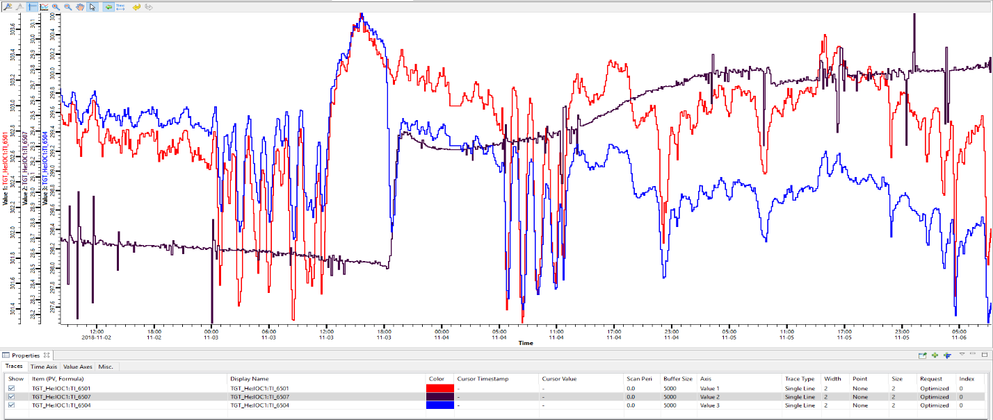
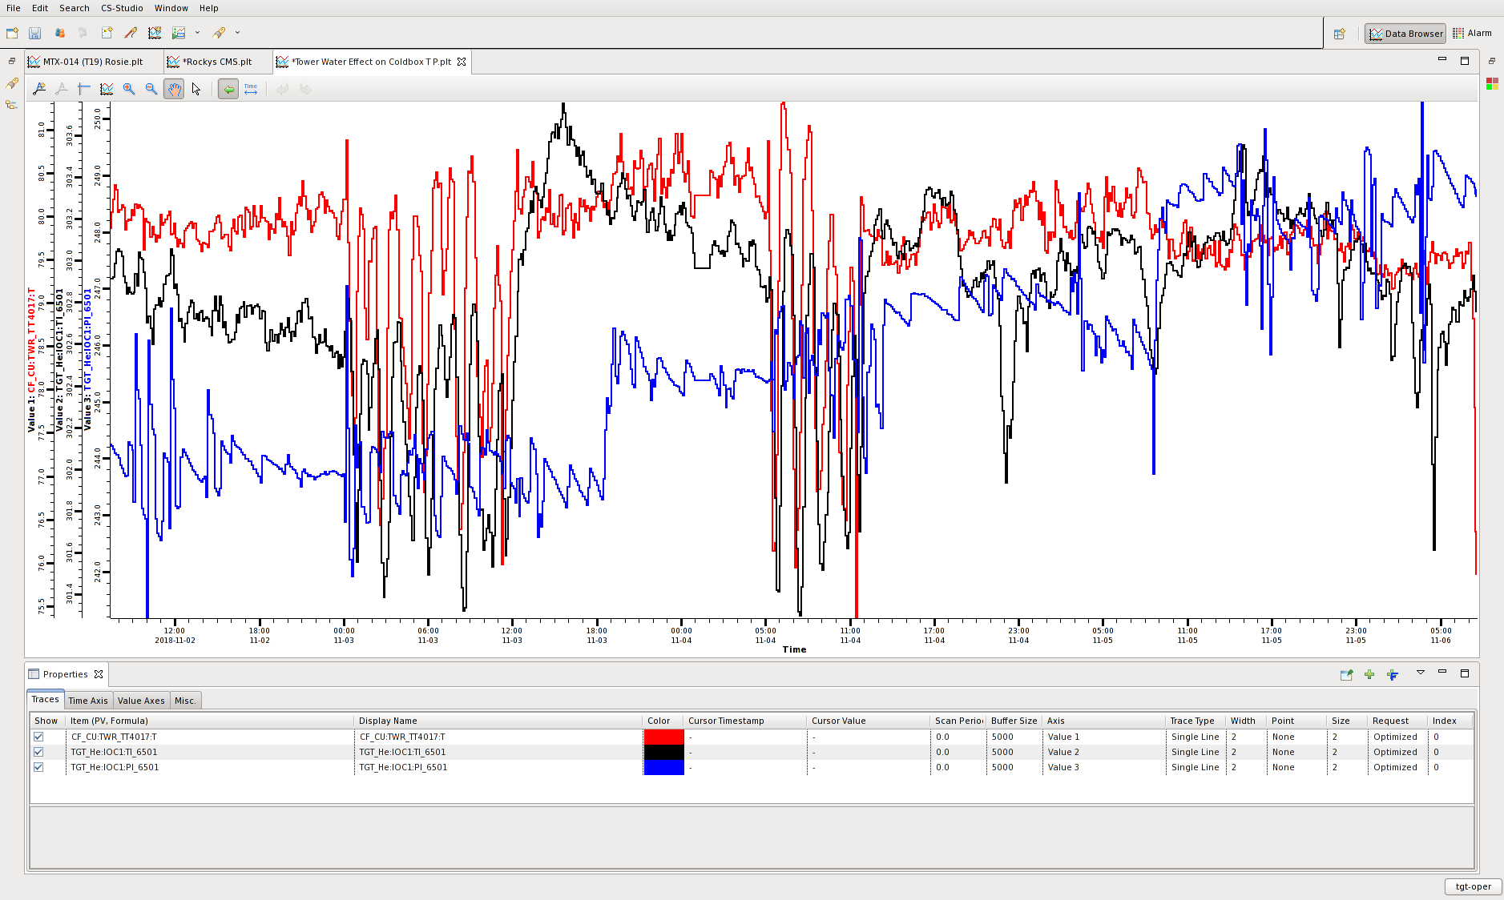
The next plot show beam power vs He/H2 flow control valve positions prior to excursion till now.
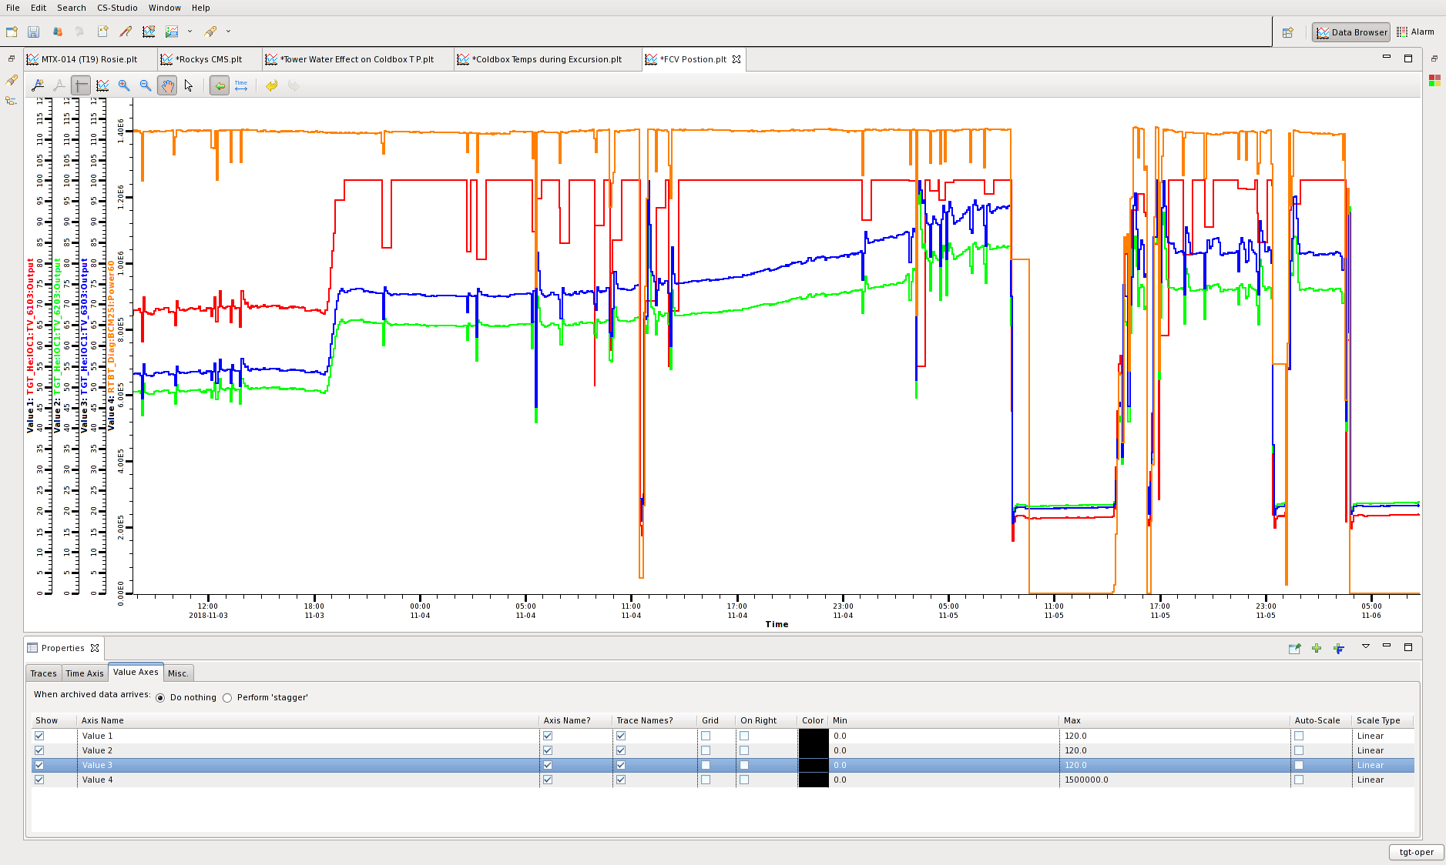
This plot shows compressor discharge pressure, High Pressure Header heat exchanger outlet temp, and turbine outlet temp prior to excursion to now.
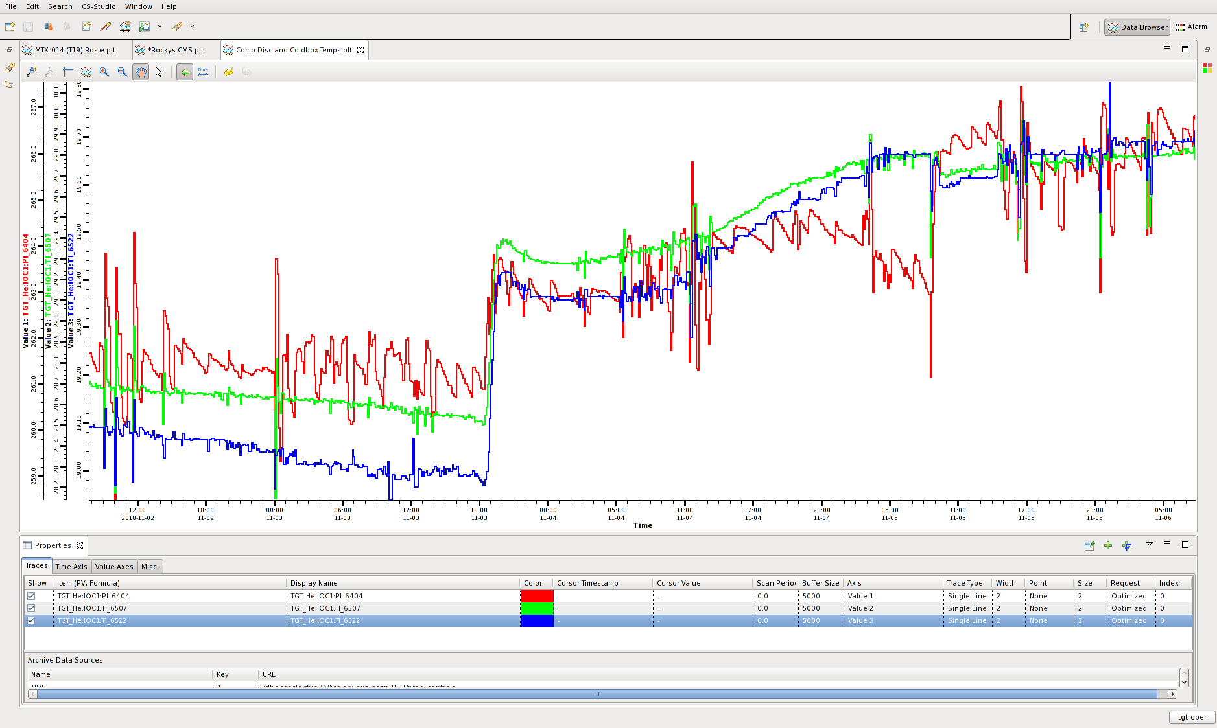
Other points, the Linde analyzer showed no increase in contaminants prior to or during the excursion period. No adjustments had been made to the system in a few weeks. All plotting thus far has not shown any other major points of interest, just effects of either temperature swings or temperature increase.
It seems that possibly during the temperature swings, then the temperature increase (hump), that some contaminant (air, water, N2, oil?) within one of the heat exchangers may have moved.
- 11/6/2018 Raised TIC-6502 up by 0.5 to 24.0K, raised H2 loops up in Temp Control Mode by 0.4K, helium was then vented off the accumulators to lower H2 pressures to ~188.0 psig.
- 11/07/2018 Loaded carbon in new ORS, 11.5 bags for each vessel.
- CMS warm up on 11/20/2018. Linde aligned to LPH during warm up.
Outage
- Purge/backfill hydrogen system with helium.
- Installed new Oil Recovery Skid (old ORS still in place with severed piping). New controls for heat tape on the carbon vessels installed, with new transformer for new load.
- Started carbon drying on ADS-6601 11/30/2018. Started very wet, blowing out moisture. Heat tape at 250.0F and N2 heater at 400.0F.
- Replaced compressor outlet valve 12/01/2018.
- Coldbox HV-6522 found to be leaking by. Valve has been rebuilt 12/07/2018.
- Sampled the Buffer Tank to the Linde cabinet for 24 hours. Readings are N2 1.73 ppm, H2O 0.73 ppm, Oil 0.65 ppm, OilAero 3.3 ppb 12/12/2018.
- Regen purifier.
- Coldbox pressure transducer leak fixed PI-6510 12/14/2018.
- Installed new valve on Linde to allow LPH sampling 12/15/2018.
- Pressure tested new piping on new ORS 12/17/2018.
- Purification run 12/18/2018.
- Vacuum isolation valve for Loop 2 replaced SV-6210 1/2/2019.
- Tested and calibrated the H2 sensors in HUR exhaust 12/27/2018.
- Purifier VJ lines and Vacuum space pumped down 1/6/2019.
- Hydrogen Cabinet and Helium Panel air tubing replaced.
- Added ~4.5 gallons oil to compressor (part Anderol and part Allstoke) 1/7/2019.
- Seal replaced on compressor 1/8/2019.
- Dual witch’s hat filters changed 1/8/2019.
- Replaced pressure transduce PI-6510 due to instrument leak 1/8/2019.
1/10/2019 Run
- Cooldown started on 1/10/2019, but had to abort due to leak by of HV-6522.
- HV-6522 valve body removed and a blank was installed in its place. This valve would only be used to send gas from the Adsorber back to the LPH (never performed) 1/11/2019.
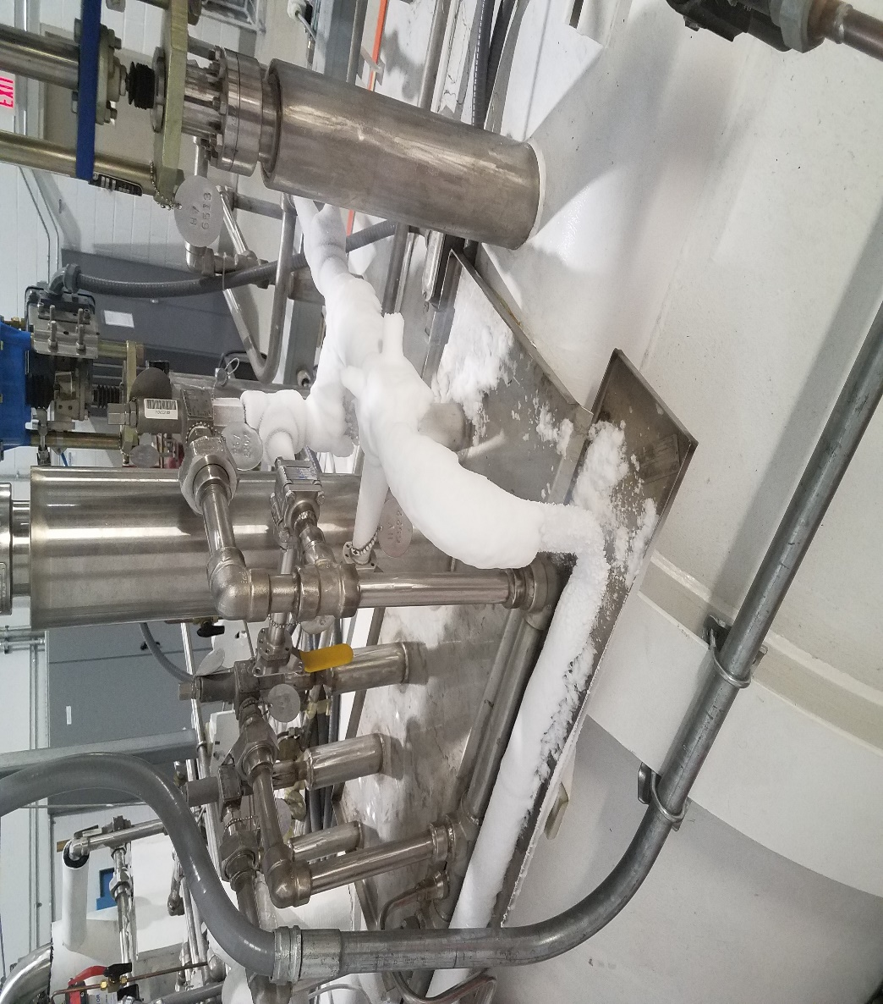
- Cooldown of CMS on 1/12/2109.
- The Linde unit was swapped over to the Helium Buffer Tank at ~1000 to ~1240. Readings was stable at following values: 1/29/2019
N2 at 0.1 ppm H2O at 0.7 ppm Oil at 0.4 ppm
- Oil level in the Bulk Oil Seperator vessel middle sight glass was found to be significantly lower from previous week. The sight glass on the first stage coalescer vessel oil drain back line was also found to be free of oil, with the second stage coalescer vessel with a higher rate of oil flow back.
At that time, the first three coalescer vessels throttle valves on the oil drain back lines was open at two full turns (5 full turns is full open).
First step was shutting the throttle valve on third coalescer, and then throttling shut on second coalescer. Flow of oil was then seen in first coalescer drain back sight glass. Eventually, the level in the Bulk Oil Seperator returned to mid-level in middle sight glass.
Flow out of the first coalescer has now stopped again. Second coalescer throttle valve has been shut and then reopened just to point of seeing oil flow in the sight glass. First coalescer at this time still has no flow, continuing to monitor.
The filter for the First coalescer drain back line was removed on 1/30/2019. Flow is normal out of First and Second, Third still isolated.
- RGA on Coldbox vacuum space showed no indication of in-leakage or internal leak. Scan was normal. RGA on HTL loop 1 showed only off-gassing within the piping. No indication of in-leakage or water, H2, or air. Scan was normal. 2/11/2019
- Throttled all three coalescer drain back valves during run to push oil back to compressor. Final oil level in compressor is below 2nd sight glass (slight slosh at bottom). Oil was found in all three coalescer vessels during run.
- 3/26/2019 Warm-up of system. This run has been awesome. System performed better than it has in many years.
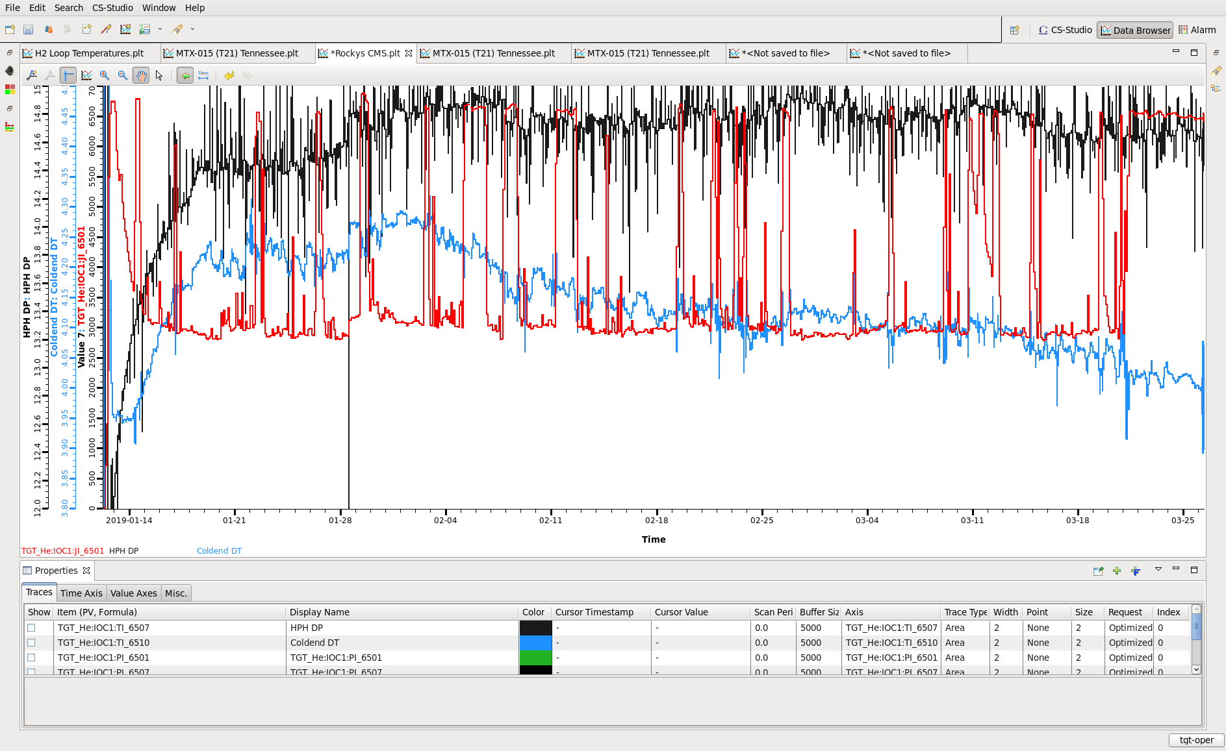

Outage
- 3/29/19 HPH and LPH from spool pieces to Coldbox inlet and outlet valves have been baked with heat tape and pumped on with cryotraps. Heat tape turned off 4/1/19.
- HPH and LPH from witch’s hat station to the spool pieces at the Coldbox have been cleaned with alcohol soaked rags and then dry rags.
- 4/1/19 Heat Exchanger Module end cap removed and leak check was performed on inside. Leak was confirmed, but due to super insulation, could not be pinpointed. Leak at -4 to -3 range.
- 4/3/19 HV-6640 and HV-6646 used for heated nitrogen have been replaced with high temperature rated valves.
- 4/3/19 Filters in the oil drain back lines of the ORS have been removed.
- 4/5/19 Tubing from FI-6501 to the HPH cleaned, had some carbon buildup.
- 4/10/19 Carbon bed ADS-6602 drying started.
- 4/10/19 Initial BOS filters changed. 5/23/19 BOS filters changed again.
- 4/30/19 New vacuum pumps installed on the Heat Exchanger Module and Transfer Lines.
- 5/7/19 Flame Detectors Annual Maintenance and Verification performed SAT.
- 5/15/19 Vacuum valve on the top of the Purifier has been changed.
- 5/20/19 Purification run aborted due to low oil level. BOS filters failed causing oil to collect in upper portion of vessel.
- 5/28/19 PRV-6202 and RD-6202 have been changed out.
- 5/30/19 FSL-6001 flow switch has been changed out with new switch.
- Getters regenerated, Loop 1 had to be regenerated several times due to decrease of vacuum.
- BOS filter issue was the vendor sent us the wrong filters. During installation, the filters began collapsing during torque down. Installed second set and tried purification run, but oil leaked by. Third set was installed and are correct now. Vendor has sent correct filters.

June 2019 Run
- 6/19/19 Start up of system.
- 6/27/2019 The pressure controller for Hydrogen Loop 1 was adjusted on PIC-6101 from 188.3 to 188.4 psig and the Coldbox temperature controller was adjusted on TIC-6502 from 23.9 to 23.8K.
- 6/28/2019 The pressure controller for H2 Loop 1 PIC-6101 was adjusted up from 188.4 to 188.5 psig.
- 7/2/2019 The Linde Multi-Component Analyzer has been lined up to sample the Low Pressure Header. The Pyrolyzer is not online due to not high enough pressure to operate.
- 7/2/2019 The pressure controller for Hydrogen Loop 1 PIC-6101 has been adjusted from 188.5 to 189.0 psig.
- 7/11/2019 Coldbox Temperature Controller TIC-6502 lowered from 23.6K to 23.3K.
- 7/11/2019 During CMS troubleshooting, the Coldbox dew point transmitter at the turbine supply line was capped off downstream of the solenoid vent valve and the Coldbox vacuum pump was isolated.
- 7/11/2019 Due to the Helium Refrigeration System degrading, the Helium System and Hydrogen System adjustments was made. The hydrogen temperatures in the hydrogen loops was raised as follows:
Temperature controller for H2 Loop 1 TIC-6103 was raised from 20.2K to 21.3K and hydrogen was vented to ~188.0 psig and helium on the backside of the accumulator was vented.
Temperature controller for H2 Loop 2 TIC-6203 was raised from 20.4K to 20.7K and helium on the backside of the accumulator was vented to lower hydrogen pressure to ~185.0 psig.
Temperature controller for H2 Loop 3 TIC-6303 was raised from 20.4K to 20.8K and helium on the backside of the accumulator was vented to lower hydrogen pressure to ~185.0 psig.
The compressor suction pressure was raised from 40.7 psig to 41.0 psig.
- 7/11/2019 The Linde sampling point was changed to sample the Helium Buffer Tank for several hours and has now been changed back to sample the High Pressure Header.
- 7/12/2019 The Coldbox vacuum cart has been re-aligned to pump on the vacuum vessel.
- 7/12/2019 The helium vacuum jacket lines from the Coldbox to the hydrogen system have been checked for insulating vacuum. Vacuum range is ~2 micron on each line.
- 7/15/2019 The Linde Multi-Component Detector was lined up to analyze the LPH. Pyrolyzer does not have enough pressure to operate.
- 7/17/2019 The helium supply line from the High Pressure Header to the Linde Cabinet supply valve has been replaced with flex line to verify if installed supply tubing is free of oil residue. Readings will be observed on the Linde analyzer. Flex line was installed on 7/16/2019 at 1230.
- 7/17/2019 The Linde units was secured to replace the flex hose from the High Pressure Header to the Linde Cabinet with 1/8" tubing. The Linde units was brought back online at 1324.
August 2019 Run
- 8/17 0654 Delayed CMS cool down due to increased Nitrogen level when switching to normal flow line up. Placed CMS back in full flow purification and will evaluate system condition with system engineers.
- 8/17 1057 Began cooldown of the Cyrogenic Moderator System.
- 8/17 2115 CMS has been cooled down to 18.5k.
- 8/19 0821 started adjusting more closed the drain back line valve on Coalescer 4.
- 8/19 1122 Filled Buffer Tank from Helium Trailer through Purifier.
- 8/20 0700 Vacuum in H2 Loops 1 and 2 have been erratic, but has since stabled out.
- 8/20 0800 the Linde units was removed from the cabinet and placed in shipping containers to be sent to vendor for inspection, repair, and calibration.
- 8/20 0940 the oil drain back valves from the Coalescer vessels to the Helium Compressor was adjusted.
- 8/20 1340 the oil drain back valves from the Coalescer vessels to the Helium Compressor was adjusted again.
- 8/20 1351 the Helium Buffer Tank was filled from the Helium Tube Trailer through the Helium Purifier.
- 8/21 1017 the Helium Buffer Tank was filled from the Helium Tube Trailer through the Helium Purifier.
- 8/22 0836 the Helium Buffer Tank was filled from the Helium Tube Trailer through the Helium Purifier.
- 8/22 1017 the Linde units was secured from sampling the HPH.
- 8/23 0807, the Linde units was secured from sampling the HPH.
- 8/23 1330, the carbon bed ADS-6601 on the Oil Recovery Skid was isolated and vented to ~50.0 psig. The heat tape on the outside of the vessel (under the insulation) has been powered on with a setpoint of 300.0F and will remain on until Monday. Then, a cryotrap vacuum cart will be connected and vessel pumped down and backfill with helium.
- 8/27 0715, the Linde units was purged with helium and placed online sampling the HPH.
- 8/27 1442 The carbon bed ADS-6601 on the Oil Recovery Skid has been vented and the cryotrap vacuum cart is now pumping on vessel. Heat tape remains on at 300.0F.
- 8/28 0705, the LN2 dewar supplying the cryotrap vacuum cart was changed out.
- 8/28 1330 on 8/27/19 the Helium Buffer Tank was filled from the Helium Tube Trailer through the Helium Purifier.
- 8/28 0900, the cryotrap vacuum cart was changed out with CHL's vacuum cart. Restarted the pumping on ADS-6601.
- 8/28 At 1153, the Linde units was secured from sampling the HPH. Final local readings:
H2O 0.9 ppm
N2 0.4 ppm
Oil 0.2 ppm
OilAero 2.0 ppb
- 8/28 1210, the Helium Buffer Tank was filled from the Helium Tube Trailer through the Helium Purifier.
- 8/28 1230, the Helium Purifier was isolated, vented to 25.0 psig, and heated nitrogen flow started through the carbon bed.
- 8/29 The following activities was performed for CMS today:
1. At 0730, the Helium Purifier was vented to ~10.0 psig and a cryotrap vacuum cart was connected and pumping started. Heated nitrogen continues to flow through the coil of the carbon bed.
2. At 1515, the cryotrap pumping on the Helium Purifier was pulled for inspection. Trap was replaced and pumping has resumed.
3. At 1502, the heat tape on the outer vessel of ADS-6601 was secured and cryotrap was isolated for trap inspection. Pressurized ADS-6601 to ~115.0 psig and will leave overnight.
- 8/30 0930, the cryotrap trap was pulled for inspection. Trap was replaced and continuing to pump on Purifier.
- 8/30 1215, the cryotrap vacuum cart was secured from pumping on the Helium Purifier. Trap was pulled for inspection which showed no more contaminates froze on surface of trap. The Helium Purifier is now being cooled down for operation.
- 8/30 1416 The Helium Purifier is back in operation lined up from the Helium Buffer Tank to the Compressor Suction.
- 9/3 0845, the Linde units was placed online sampling the HPH after a 1 hour purge with helium.
- 9/4 1250, filled the Helium Buffer Tank from the Helium Tube Trailer through the Helium Purifier.
- 9/6 1053 Approximately 4 gallons of processed Allstoke oil was add to the Helium Compressor at the upper suction port. Currently, the middle sight glass shows ~3/4 full of oil.
- 9/6 1315, the Linde units was secured from sampling the HPH.
- 9/6 1330, the Helium Buffer Tank was filled from the Helium Tube Trailer through the Helium Purifier.
- 9/13 1415 The following adjustments were made to the CMS:
PIC-6401 was lowered from 40.0 to 39.5 psig
PIC-6404 was lowered from 255.0 to 253.5 psig.

Outage 9/2/2019
- 10/2/2019 Warm-up of CMS completed. Hydrogen Loop 1 control valve had issue after going to Temperature Control Mode. Valve tried to shut (stopped at 5% open due to minimum stop) which initially caused the hydrogen temps and pressures to rise.
- 10/3/2019 The helium compressor was secured after Coldbox temperatures reached normal warm-up range, the Linde analyzer sampling the LPH was isolated and secured, heated helium flow to the 20K Adsorber was secured, and LO/TO performed on the system is preparations of maintenance work.
- 10/4/2019 0830 Started the warm-up of the Helium Purifier by flowing heated nitrogen through coil in carbon adsorber.
- 10/4/2019 At 1120, the Coldbox flow path was vented of helium (there was a heavy smell of oil while venting) and nitrogen flow established through the Coldbox. Nitrogen is flowing in at the port on the LPH, through the heat exchanger, with the He/H2 heat exchangers isolated, turbine circuit is isolated, carbon adsorber is isolated, flowing through HPH side of heat exchanger, and venting at HPH port. Initial dewpoint readings prior to turning of heater with nitrogen flowing for ~30 minutes was -55.90C, H2O at 19.0ppm, and temperature at 68.56F. Heater was turned on at ~1150 with a set point of 140.0F.
- 10/4/2019 The helium compressor discharge header was vented off in preparations of tying in the old oil recovery skid to the helium system.
- 10/4/2019 Dewpoint readings on Coldbox heated nitrogen purge at 1300 -70.59C, H2O at 2.0 ppm, temp at 78.01F. At 1800, -52.91C, H2O at 14.0 ppm, temp at 104.8F.
- 10/5/2019 The heated nitrogen flow through the coils on the Helium Purifier carbon bed is ongoing. Vented helium from purifier and lined up a cryotrap vacuum cart and began pumping at 0810.
- 10/5/2019 Dewpoint readings at Coldbox heated nitrogen purge. 0736 -53.99C, H2O at 24.0 ppm, temp at 112.83F. 0924 -53.62C, H2O at 25.0 ppm, temp at 113.27F, 1012 -52.79C, H2O at 28.0 ppm, temp at 113.48F.
- 10/5/2019 At 1030, carbon removal of ADS-6601 was started.
- 10/5/2019 At 1156, the cryotrap vacuum was at ~5.0 mTorr. Trap was pulled for visual inspection that showed very little moisture accumulation froze to trap. Purifier was pressed up to ~25.0 psig helium from the Helium Tube Trailer. Heated nitrogen was secured.
- 10/6/2019 Dewpoint meter readings on the heated nitrogen purge of Coldbox heat exchangers:
07:39 -51.19C, H2O at 34.0 ppm, temp at 115.02F.
09:21 -51.80C, H2O at 32.0 ppm, temp at 115.09F
12:20 -51.50C, H2O at 33.0 ppm, temp at 115.03F
13:20 -51.42C, H2O at 33.0 ppm, temp at 115.20F
- The cryotrap vacuum cart was placed back online pumping on the carbon bed of the Helium Purifier at ~0730 and was secured at ~1330. Vacuum was at 12.0 mTorr. Trap was pulled with no evidence of additional moisture. Helium Purifier has been backfilled with ~100.0 psig helium and cooled down, ready for normal operation.
- The three hydrogen loops have been pressure purged three times with helium, then purged/backfilled with helium three times.
- Work continues on the tie in of the old Oil Recovery Skid.
ADS-6601 carbon bed vessel on the new Oil Recovery Skid has been readied for carbon addition.
- 10/9/2019 The heated nitrogen purge of the Coldbox heat exchangers was secured at 0910 due to Target Bldg nitrogen outage. The following dewpoint meter readings was taken:
6:28 -50.09C, H2O at 39.0 ppm, temp at 111.58F
7:54 -50.69C, H2O at 36.0 ppm, temp at 112.36F
- At 0930, a cryotrap vacuum cart was placed on the HPH inlet port with PV-6517 SHUT and the 20K Adsorber isolated. At 1230, the cryotrap vacuum cart was secured and trap pulled for inspection. Trap removed showed very minor evidence of water from the HPH.
- At 1345, the heated nitrogen purge through the Coldbox heat exchangers was re-established. Heater on at 140.0F.
- The Helium Compressor discharge piping modifications status: All piping from the compressor discharge isolation valve to both the Oil Recovery Skids have been internally cleaned SAT. New valves have been installed but bolts have not been torqued. Discharge isolation valve HV-6428 was removed and cleaned of debris, and replaced in system. HV-6428 has some scarring on the sealing surface and some trapped debris, mainly metal shavings. Will determine tomorrow if replacing with new valve Provo had ordered.
- P-6300 circulator was leaked checked at an ~1 scale leak. Bolts was rechecked for spec torque, leak checked again with a better result. Will recheck in the morning to determine if leak rate was real or trap under circulator base plate.
- 10/10/2019 The heated nitrogen purge through the Coldbox heat exchangers was secured at 06:24. The last reading on dewpoint meter:
06:16 -51.96C, H2O at 31.0 ppm, temp at 112.10F
06:24 -51.19C, H2O at 34.0 ppm, temp at 112.10F
- At 06:33, the cryotrap vacuum cart started pumping on the LPH with the He/H2 heat exchangers isolated, DPIC-6523 SHUT, and PIC-6517 SHUT.
- At 13:25, the cryotrap vacuum pump was secured from pumping on the LPH. Trap was pulled and showed very little evidence of moisture on trap.
- At 13:55, the heated nitrogen purge of the Coldbox heat exchangers was started. The following dewpoint meter readings was taken:
14:01 -69.47C, H2O at 3.0 ppm, temp at 71.14F
14:02 -58.10C, H2O at 14.0 ppm, temp at 86.74F
14:04 -55.76C, H2O at 19.0 ppm, temp at 87.84F
14:09 -59.56C, H2O at 12.0 ppm, temp at 90.11F
14:13 -60.51C, H2O at 10.0 ppm, temp at 91.29F
- At 14:15, the He/H2 heat exchanger HX-6100 was un-isolated and DPIC-6523 was shut to 20.0%. Flow is now flowing through Coldbox heat exchangers from LPH inlet, through HX-6100, exhausting through HPH outlet port. The following readings was taken on dewpoint meter:
At 14:15 -57.73C, H2O at 15.0 ppm, temp at 91.88F
- The getters In H2 loops 1 and 2 have been regenerated.
- Leak still present on H2 loop 3 circulator. Will remove and change o-ring and base plate gasket again, along with inspecting for possible physical cause of leak.
- Valves have been installed on the piping modification on compressor discharge piping.
- 10/11/2019 At 07:42, the heated nitrogen flow through HX-6100 was secured and started flowing through HX-6200. The final dewpoint readings on HX-6100:
07:41 -50.15C, H2O at 39.0 ppm, temp at 113.97F
- First readings on HX-6200:
07:50 -50.30C, H2O at 38.0 ppm, temp at 113.98F
13:50 -50.80C, H2O at 36.0 ppm, temp at 113.92F
- At 08:15, the CHL carbon type addition to ADS-6601 was started. Carbon addition has been secured and will resume tomorrow. There will be 2 styles of carbon, both coconut based, added to ADS-6601
- 10/14/2019 The heated nitrogen flow through the Coldbox heat exchangers is still ongoing. Latest dewpoint meter readings:
06:53 -48.97C, H2O at 45.0 ppm, temp at 113.98F
10:27 -49.73C, H2O at 41.0 ppm, temp at 113.86F
- The heated nitrogen drying of the carbon in ADS-6601 was secured at 08:20. Dewpoint meter reading prior to securing was at -52.0F.
- At 08:30, Cryotrap was started pumping on ADS-6601 carbon bed.
- At 13:05, the cryotrap was pulled on the vacuum pump that was pumping on carbon in ADS-6601. Trap showed heavy icing indicating carbon has a lot of moisture. Heated nitrogen flow through carbon has been re-established.
- 10/15/2019 The bottom vent on the Helium Buffer Tank was opened to inspect for oil/water collected in bottom of tank. No oil/water was present during venting of helium.
- The heated nitrogen drying on the carbon bed of ADS-6601 dewpoint is at -78.0F. Heated flow is ongoing, will cryopump tomorrow morning.
- The Linde units was placed online sampling the Helium Buffer Tank at 09:10.
- At 14:10, the Linde units was secured from sampling the Helium Buffer Tank. Final readings:
H2O = 1.3 ppm
N2 = 0.9 ppm
Oil = 0.2 ppm
OilAero = 17.0 ppb
- The heated nitrogen flow through the Coldbox heat exchangers is ongoing. Readings on the dewpoint meter:
08:17 -49.08C, H2O at 44.0 ppm, temp at 114.93F
14:11 -50.21C, H2O at 39.0 ppm, temp at 114.37F
- All new installation on valves and flanges on the discharge of the Helium Compressor has been leaked checked SAT with Inficon.
- The Helium Compressor After-Cooler Tower Water supply and return valves was isolated and drained. Compressor was pressed up to 30.0 psig helium for 2 hours. Tower Water side was checked with Inficon for helium leak, no leak was observed. Tower Water has been realigned to normal flow.
- The bottom vent on the old ORS carbon bed was opened to vent any residual carbon dust out. No dust, but ~1/4 cup of oil was drained.
- There is a bad helium leak on the oil drain back line assembly on the Bulk Oil Separator. Will discuss with David Provo tomorrow on rebuilding that line.
- Matt Howell has delivered the new coalescer assembly plates to Mechanics.
- 10/17/2019 At 06:55, the flow of nitrogen to the Coldbox heat exchangers was decreased, final dewpoint meter readings prior to throttling back:
06:51 -51.04C, H2O at 35.0 ppm, temp at 115.88F
- The following dewpoint meter readings was taken after flow was decreased:
07:12 -53.37C, H2O at 26.0 ppm, temp at 112.87F
07:20 -54.11C, H2O at 24.0 ppm, temp at 112.18F
- At 07:22, the heated nitrogen flow was secured to the Coldbox in preparations to cryopump the High Pressure Header.
- At 07:31, the cryotrap vacuum pump was placed pumping on the High Pressure Header.
- At 07:52, the dewpoint reading on the drying of the carbon in ADS-6601 was at -87.0F.
- At 09:30, the heated nitrogen flow to the carbon in ADS-6601 was secured and cryotrap vacuum cart was started.
- The four coalescer vessels on the new Oil Recovery Skid was opened, coalescer assemblies removed, inspected, and coalescer elements replaced with Parker Bolston elements.
- The cryotrap vacuum carts are still pumping on the High Pressure Header and ADS-6601. Traps will be pulled tomorrow morning.
- 10/18/2019 This morning, the trap was pulled on the cryotrap vacuum cart pumping on the High Pressure Header. Trap was very clean. High Pressure Header was pressed up with helium to ~10.0 psig.
- This morning, the trap was pulled on the cryotrap vacuum cart pumping on the carbon bed in ADS-6601. Trap was very clean. ADS-6601 was pressed up with helium.
- The bolts for the new Oil Recovery Skid have been torqued following coalescer replacement yesterday. Leak checks have not been performed.
- Mechanics are working on cleaning strainers and repairing leaks found on the helium compressor.
- A section of tubing from the BOS vessel drain back line to the compressor suction was found that is laying against an angled support. Over time, vibration has worn an area down to the point of, how does this not leak. This will be replaced tomorrow.
- 10/21/2019 At 08:30, the cryotrap vacuum pump was starting pumping on the Coldbox Adsorber. At 10:30, the trap was pulled which came out very clean, Adsorber pressurized to ~20.0 psig with Target Bldg helium. At 12:45, pressure was vented from Coldbox Adsorber and cryotrap vacuum cart started again. At 15:40, the trap was pulled on the cryotrap vacuum cart pumping on the Coldbox Adsorber. Trap was clean. Adsorber backfilled with Target Bldg helium to ~20.0 psig. This completes the 2nd cycle.
- At 07:30, the Tower Water leak on the Helium Compressor outlet vent valve piping was repaired and leak tested SAT. Normal Tower Water flow has been restored to system.
- The carbon that was in ADS-6602 has been removed. 1 bag of carbon was added, will resume tomorrow depending on weather.
- The new pressure transmitter PT-6567 has been installed and leak checked SAT.
- 10/22/2019 New sight glass was installed on the Bulk Oil Separator oil drain back line. Epoxy 24 hour cure time will be over at 14:45 tomorrow.
- Four cycles of pressure purges has been performed on the helium compressor using helium from Helium Buffer Tank through the Helium Purifier. Last pressure purge will be complete tomorrow after 14:45.
- At 07:00, the pressure was vented from the Adsorber and cyrotrap vacuum cart started for pump down number 3.
- At 08:00, pressure was vented off the HPH and cryotrap vacuum cart started.
- At 10:53, the trap was pulled on the cyrotrap vacuum cart pumping on the Coldbox Adsorber. Trap was clean. Adsorber backfilled with Target Bldg helium to ~20.0 psig. Cycle 3 complete.
- At 12:30, the cryotrap vacuum cart was started pumping on the LPH.
- At 16:00, the cryotrap vacuum cart was starting pumping on the complete Oil Recovery System (old and new Oil Recovery Skids), carbon beds remain isolated.
- At 16:30, the trap was pulled on the cryotrap vacuum cart pumping on the HPH, vacuum was at 200.0 mTorr. Trap was very clean. Pressed up the HPH with Target Bldg helium to ~2.0 psig.
- At 16:35, the trap was pulled on the cryotrap vacuum cart pumping on the LPH, vacuum was at 350.0 mTorr. Trap was very clean. Pressed up the LPH with Target Bldg helium to ~2.0 psig.
- 12.5 bags of Sorbonorit B4 carbon has been added to ADS-6602.
- 10/23/2019 At 07:15, the cryotrap vacuum carts was started pumping on the HPH and LPH. HPH pumping now lined up back to the witch's hat station. LPH now lined up to the inlet isolation valve to the helium compressor. Vacuum carts will remain pumping overnight.
- At 08:30, the vacuum gauge PT-6010 for the Hydrogen System Heat Exchanger Module was replaced and leak checked SAT.
- At 10:30, the trap on the cryotrap vacuum cart pumping on the complete Oil Recovery System was pulled for inspection. Trap had a lot of buildup of moisture and oil. Backfilled the system with Helium Tube Trailer helium to ~20.0 psig.
- At 12:00, the cryotrap vacuum cart was started pumping on carbon bed in ADS-6601. External vessel heat tape has been secured. Vacuum cart will remain pumping overnight.
- At 13:00, two cycles of pressure purges (pressed to ~20.0 psig helium from Helium Tube Trailer and held for a minimum of 40 minutes) was completed on the combined Oil Recovery Skids.
- At 13:30, the combined Oil Recovery Skids was started pumping on the cryotrap vacuum cart. Vacuum cart will remain pumping overnight.
- At 14:00, a heated nitrogen flow was started to ADS-6602 carbon bed. Inline nitrogen heater set to 400.0F with external vessel heat tape set to 300.0F.
- Controls investigating diode TI-6507, due to reading at a failure state 326.7K.
- 10/24/2019 At 07:45, the trap was pulled on the cryotrap vacuum pump pumping on the HPH. Trap was clean. Backfilled with Target Bldg helium to ~20.0 psig.
- At 07:50, the trap on the cryotrap vacuum cart was pulled pumping on the LPH. Trap was clean. Backfilled with Target Bldg helium to ~20.0 psig.
- At 08:50, the trap on the cryotrap vacuum cart pumping on the complete Oil Recovery Skids was pulled. Trap had a lot of moisture built up. Backfilled from the Helium Tube Trailer to ~20.0 psig.
- At 14:30, the cryotrap vacuum cart was started pumping on the Witch's Hat Station at the pump out port on the HPH at the inlet to the Coldbox.
- At 10:30, the cryotrap vacuum cart was started pumping on the combined Oil Recovery Skids until 15:00. Trap was pulled and clean. Skids backfilled with helium from Helium Tube Trailer.
- The Coldbox diode TI-6507 was checked on spare channel and determined to be failed also. Diode will be changed tomorrow.
- This morning, the trap on the cryotrap vacuum cart pumping on ADS-6601 was pulled for inspection. Trap had a lot of moisture build up. Backfilled with helium and found three valves to have packing leaks and one valve had a valve body leak. Packing was tightened and new Teflon gasket replaced on valve body leak, recheck with leak detector and determined no leaks. Cryotrap vacuum cart was started pumping on ADS-6601 again at 14:30.
- At 13:00, the combined Oil Recovery Skide oil drain back lines (which have been isolated) was pressurized with helium. Several leaks was found and fixed, all leak checks are now SAT.
- 10/28/2019 At 07:30, the Helium Buffer Tank was filled directly from the UHP 16 pack of helium.
- At 08:00, the cryotrap vacuum cart was started pumping on ADS-6602. At 13:30, the trap on the cryotrap vacuum cart pumping on ADS-6602 was pulled for inspection. Outside of trap was frosted over but trap was clean. Leak check performed found to leaking valve stem packing. Leaks was fixed. Cryotrap once again pumping on vessel.
- At 08:04, the Linde units sampling from the outlet of the final coalescer vessel was secured. Final readings:
H20 1.1 ppm
N2 0.7 ppm
Oil 0.3 ppm
OilAero 9.0 ppb
- At 06:50, hydrogen HX-6200 was lined up for purification run and HX-6100 was isolated. At 17:30, Helium to hydrogen heat exchanger HX-6200 has been isolated and HX-6300 has been lined up for purification run.
- At 08:30, the cryotrap vacuum cart was started pumping on the Coldbox Adsorber. At 12:00, the trap on the cryotrap vacuum cart pumping on the Coldbox Adsorber was pulled for inspection. Trap was clean. Adsorber backfilled with system helium.
- At 13:00, the vacuum jacketed lines for the helium to Hydrogen System heat exchangers was pumped down and checked for vacuum level. Readings was at 22 and 25 microns.
- The diode TI-6507 was reading 326.7K on channel A and was swapped to channel B. Channel B also reads 326.7K. Swapped back over to channel A.
- At 14:00, the cylinder in location B1 valve was not opening on initial cylinder installation. Investigation found the instrument air connector was broke. Connector was replaced and cylinder valve operators SAT. Cylinder installation is now complete and test SAT.
- At 15:30, the helium cylinders in the Helium Panel was replaced and test SAT.
- At 10:30, the getters in the vacuum space of Hydrogen Loops 1 and 3 transfer lines was replaced. The getter in Hydrogen Loop 3 has been activated.
- ~9 gallons of Allstoke oil was added to the Helium Compressor to the bottom of the top sight glass.

October 2019 Run
- 10/30/2019 CMS cooldown complete.
- 11/1/2019 Linde sampled from the HPH. Final readings: H2O 0.6 ppm, N2 0.4 ppm, Oil 0.2 ppm, OilAero 1.0 ppb. 5 hour sample time.
- 11/6/2019 The online witch’s hat filter F-6604 which had a DP of 12.0 psid was shut after F-6605 was opened. F-6605 DP is 1.0 psid.
- 11/7/2019 Linde sampled from the HPH. Final readings: H2O 0.7 ppm, N2 0.5 ppm, Oil 0.2 ppm, OilAero 2.0 ppb. 5.5 hour sample time.
- 11/14/2019 Helium Compressor oil sample pulled for offsite analysis.
- 11/15/2019 Linde sampled from the HPH. Final readings: H2O 1.0 ppm, N2 0.6 ppm, Oil 0.2 ppm, OilAero 1.0 ppb. 5 hour sample time.
- 11/22/2019 Linde sampled from outlet of final coalescer vessel. Final readings: H2O 1.1 ppm, N2 0.5 ppm, Oil 0.2 ppm, OilAero 8.0 ppb. 8 hour sample time.
- 12/6/2019 Linde sampled from outlet of final coalescer vessel. Final readings: H2O 0.9 ppm, N2 0.6 ppm, Oil 0.3 ppm, OilAero 7.0 ppb. 18 hour sample time.

