Second Target Station Project:

QIKR Motion Preliminary Design Review Report

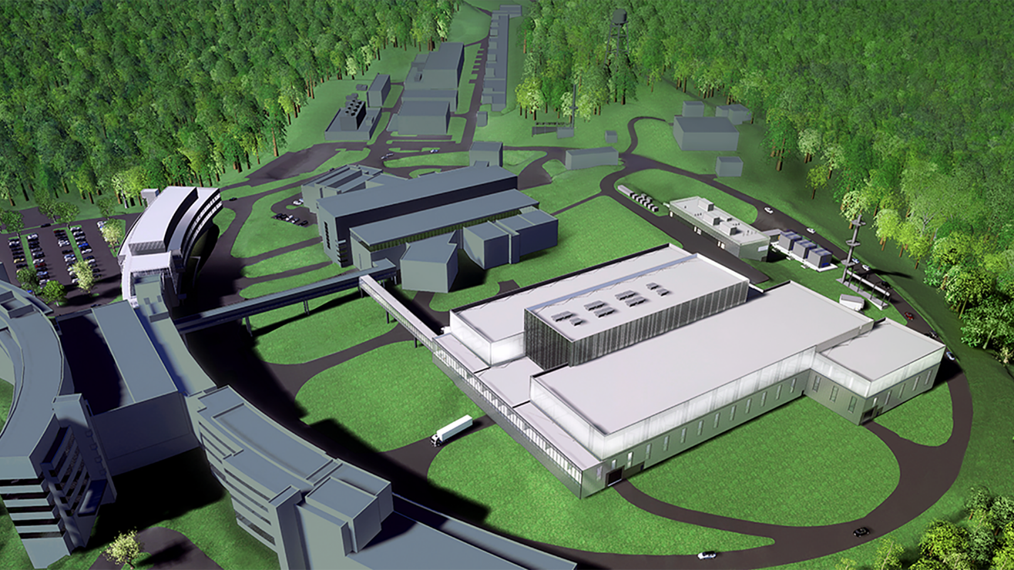

André Parizzi

Lukas Bearden

Tim Charlton

Mike Hoffmann

James McLaurin

November 2024

|  |
| --- |
| **DOCUMENT AVAILABILITY** |
| Reports produced after January 1, 1996, are generally available free via OSTI.GOV.  ***Website*** [www.osti.gov](http://www.osti.gov/)  Reports produced before January 1, 1996, may be purchased by members of the public from the following source:  National Technical Information Service  5285 Port Royal Road  Springfield, VA 22161  ***Telephone*** 703-605-6000 (1-800-553-6847)  ***TDD*** 703-487-4639  ***Fax*** 703-605-6900  ***E-mail*** info@ntis.gov  ***Website*** <http://classic.ntis.gov/>  Reports are available to US Department of Energy (DOE) employees, DOE contractors, Energy Technology Data Exchange representatives, and International Nuclear Information System representatives from the following source:  Office of Scientific and Technical Information  PO Box 62  Oak Ridge, TN 37831  ***Telephone*** 865-576-8401  ***Fax*** 865-576-5728  ***E-mail*** reports@osti.gov  ***Website*** <https://www.osti.gov/> |

|  |
| --- |
| This report was prepared as an account of work sponsored by an agency of the United States Government. Neither the United States Government nor any agency thereof, nor any of their employees, makes any warranty, express or implied, or assumes any legal liability or responsibility for the accuracy, completeness, or usefulness of any information, apparatus, product, or process disclosed, or represents that its use would not infringe privately owned rights. Reference herein to any specific commercial product, process, or service by trade name, trademark, manufacturer, or otherwise, does not necessarily constitute or imply its endorsement, recommendation, or favoring by the United States Government or any agency thereof. The views and opinions of authors expressed herein do not necessarily state or reflect those of the United States Government or any agency thereof. |
|  |

S04080600-DRD10000-R00

Second Target Station Project

QIKR MOTION Preliminary Design Review Report

André Parizzi

Lukas Bearden

Tim Charlton

Mike Hoffmann

James McLaurin

November 2024

Prepared by

OAK RIDGE NATIONAL LABORATORY

Oak Ridge, TN 37831

managed by

UT-BATTELLE LLC

for the

US DEPARTMENT OF ENERGY

under contract DE-AC05-00OR22725

Approvals

|  |  |  |  |  |  |  |  |  |  |
| --- | --- | --- | --- | --- | --- | --- | --- | --- | --- |
|  | | | | | | | ISSUE DATE: | | |
| QIKR MOTION PRELIMINARY DESIGN REVIEW REPORT | | | | | | | November 2024 | | |
| PREPARED BY | | | PROJECT | | | | DOCUMENT NUMBER: | | |
| André Parizzi | | | Second Target Station | | | | S04080600-DRD10000 | | |
|  | | |  | | | |  | | |
|  | | |  | | | |  | | |
|  | | | | | | | | | |
|  | Signature / Date | | | | | | | | |
|  | Rev. 00 | | | Date | Rev. 01 | Date | | Rev. 02 | Date |
| Technical Reviewer |  | | |  |  |  | |  |  |
|  | | |  |  |  | |  |  |
| Quality Representative |  | | |  |  |  | |  |  |
|  | | |  |  |  | |  |  |
| Instrument Systems |  | | |  |  |  | |  |  |
|  | | |  |  |  | |  |  |
|  |  | | |  |  |  | |  |  |
|  | | |  |  |  | |  |  |
|  |  | | |  |  |  | |  |  |
|  | | |  |  |  | |  |  |
|  |  | | |  |  |  | |  |  |
|  | | |  |  |  | |  |  |
|  |  | | |  |  |  | |  |  |
|  | | |  |  |  | |  |  |
|  |  | | |  |  |  | |  |  |
|  | | |  |  |  | |  |  |
|  |  | | |  |  |  | |  |  |
|  | | |  |  |  | |  |  |
|  |  | | |  |  |  | |  |  |
|  | | |  |  |  | |  |  |
| Revision | | Description | | | | | | | |
| 00 | | Initial Release | | | | | | | |
|  | |  | | | | | | | |
|  | |  | | | | | | | |

CONTENTS

CONTENTS iii

ABSTRACT 1

1. QIKR Motion Preliminary Design Review 1

1.1 Technical Review Committee 1

1.2 Presenters 1

1.3 Other Attendees 2

2. Comments 2

2.1 Introduction 2

2.2 Science Overview of QIKR and its Motion Needs 2

2.3 Implementation of Motion Needs, Overview 2

2.4 Incident Table Design Details 2

2.5 Detector and Sample Table Design Details 2

3. Review Committee Responses to Charge Questions 2

4. Summary of Recommendations 3

ABSTRACT

The QIKR instrument is a reflectometer intended to primarily investigate liquid samples. Although solid samples may also be used, most samples will be liquids with a free surface that cannot be inclined relative to horizontal. To provide an incident angle for the neutron beam on these surfaces, the beam itself is inclined. QIKR has two separate neutron beam paths, QIKR-A and QIKR-B, that each operate as an independent beamline. QIKR-A is angled upward from horizontal by 2.5° and QIKR-B is angled downward from horizontal by 2.5°. QIKR-A and QIKR-B share a maintenance shield, which actuates to either allow neutrons to pass (operating position) or to block the guide and allow safe access to the bunker when the proton beam is off (maintenance position). Each beam path has its own end station. The end station is located downstream of the guide end and is intended to position both the sample and detector and to select one of the three beam components exiting the guide. Each beam path has its own shutter and beam attenuation mechanism. The shutter blocks the beam from entering the cave when users are present, and the attenuator allows the user to reduce the beam intensity by various amounts when needed for a given experiment. The attenuator must be placed in the beam prior to the sample, and the shutter must be placed in the beam prior to the cave. The last motion component for each beam path is a sample changer that will be able to position multiple samples in the beam without requiring the user to enter the cave.

This PDR covers the all the motion components, but its focus will be on the end station systems since the maintenance shields and shutters are standardized designs that will be included in a Bunker Motion Systems PDR.

This report documents the comments and recommendations from the QIKR Motion Preliminary Design Review held November 6, 2024.

# QIKR Motion Preliminary Design Review

## Technical Review Committee

|  |  |
| --- | --- |
| Andre Parizzi (chair) | SNS Neutron Scattering Division |
| Lukas Bearden | STS Target Systems Engineering |
| Tim Charlton | SNS Neutron Scattering Division |
| Mike Hoffmann | SNS Neutron Technologies Division |
| James McLaurin | STS Accelerator Systems Engineering |

## Presenters

|  |  |
| --- | --- |
| John Ankner | QIKR Scientist |
| Danielle Wilson | QIKR Lead Engineer |
| Rudy Thermer | STS Instruments Motion Engineer |

## Other Attendees

|  |  |
| --- | --- |
| Van Graves | STS Instrument Systems Engineering |
| Leighton Coates | STS Instrument Systems Management |
| Saurabh Kabra | STS Instrument Systems Science |
| Matt Pearson | STS Integrated Control Systems Engineering |
| David Anderson | STS Systems Engineering |
| Tim Gregory | STS Quality Assurance |

# Comments

## Introduction

## Science Overview of QIKR and its Motion Needs

## Implementation of Motion Needs, Overview

## Incident Table Design Details

## Detector and Sample Table Design Details

# Review Committee Responses to Charge Questions

1. *Have system requirements been defined, and are they complete and adequate to ensure acceptable system performance?*
2. *Can the proposed system designs meet their functional and performance requirements?*
3. *Are the cost estimates and acquisition strategies reasonable?*
4. *Are the proposed preliminary designs sufficiently mature to proceed to final design?*

# Summary of Recommendations

1. Agenda

