Second Target Station Project: QIKR Shielding Preliminary Design Review Report

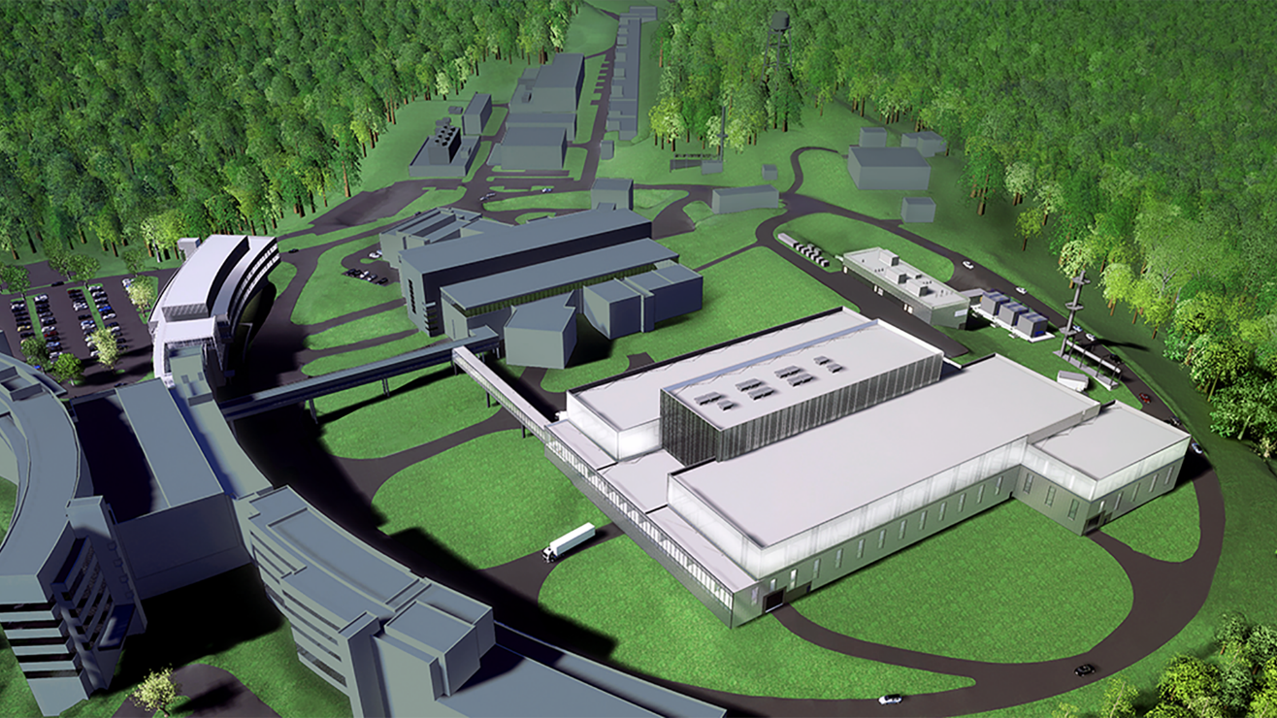

Jim Eckroth

Draft. Document has not been reviewed and approved for public release.

Franz Gallmeier

Christi Elam

Aaron Hostetler

Tommy Michaelides

March 2025

|  |
| --- |
| **DOCUMENT AVAILABILITY** |
| Reports produced after January 1, 1996, are generally available free via OSTI.GOV.  ***Website*** [www.osti.gov](http://www.osti.gov/)  Reports produced before January 1, 1996, may be purchased by members of the public from the following source:  National Technical Information Service  5285 Port Royal Road  Springfield, VA 22161  ***Telephone*** 703-605-6000 (1-800-553-6847)  ***TDD*** 703-487-4639  ***Fax*** 703-605-6900  ***E-mail*** info@ntis.gov  ***Website*** <http://classic.ntis.gov/>  Reports are available to US Department of Energy (DOE) employees, DOE contractors, Energy Technology Data Exchange representatives, and International Nuclear Information System representatives from the following source:  Office of Scientific and Technical Information  PO Box 62  Oak Ridge, TN 37831  ***Telephone*** 865-576-8401  ***Fax*** 865-576-5728  ***E-mail*** reports@osti.gov  ***Website*** <https://www.osti.gov/> |

|  |
| --- |
| This report was prepared as an account of work sponsored by an agency of the United States Government. Neither the United States Government nor any agency thereof, nor any of their employees, makes any warranty, express or implied, or assumes any legal liability or responsibility for the accuracy, completeness, or usefulness of any information, apparatus, product, or process disclosed, or represents that its use would not infringe privately owned rights. Reference herein to any specific commercial product, process, or service by trade name, trademark, manufacturer, or otherwise, does not necessarily constitute or imply its endorsement, recommendation, or favoring by the United States Government or any agency thereof. The views and opinions of authors expressed herein do not necessarily state or reflect those of the United States Government or any agency thereof. |
|  |

STS Document Number here

Second Target Station Project

QIKR SHielding Preliminary Design Review Report

Jim Eckroth

March 2025

Prepared by

OAK RIDGE NATIONAL LABORATORY

Oak Ridge, TN 37831

managed by

UT-BATTELLE LLC

for the

US DEPARTMENT OF ENERGY

under contract DE-AC05-00OR22725

Approvals

|  |  |  |  |  |  |  |  |  |  |
| --- | --- | --- | --- | --- | --- | --- | --- | --- | --- |
|  | | | | | | | ISSUE DATE: | | |
| QIKR SHIELDING PRELIMINARY DESIGN REVIEW REPORT | | | | | | | March 2025 | | |
| PREPARED BY | | | PROJECT | | | | DOCUMENT NUMBER: | | |
| Jim Eckroth | | | Second Target Station | | | | STS Document Number | | |
|  | | |  | | | |  | | |
|  | | |  | | | |  | | |
|  | | | | | | | | | |
|  | Signature / Date | | | | | | | | |
|  | Rev. 00 | | | Date | Rev. 01 | Date | | Rev. 02 | Date |
| Technical Reviewer |  | | |  |  |  | |  |  |
|  | | |  |  |  | |  |  |
| Technical Reviewer |  | | |  |  |  | |  |  |
|  | | |  |  |  | |  |  |
| Quality Representative |  | | |  |  |  | |  |  |
|  | | |  |  |  | |  |  |
| ESH&Q |  | | |  |  |  | |  |  |
|  | | |  |  |  | |  |  |
| Instrument Systems |  | | |  |  |  | |  |  |
|  | | |  |  |  | |  |  |
|  |  | | |  |  |  | |  |  |
|  | | |  |  |  | |  |  |
|  |  | | |  |  |  | |  |  |
|  | | |  |  |  | |  |  |
|  |  | | |  |  |  | |  |  |
|  | | |  |  |  | |  |  |
|  |  | | |  |  |  | |  |  |
|  | | |  |  |  | |  |  |
|  |  | | |  |  |  | |  |  |
|  | | |  |  |  | |  |  |
| Revision | | Description | | | | | | | |
| 00 | | Initial Release | | | | | | | |
|  | |  | | | | | | | |
|  | |  | | | | | | | |

CONTENTS

CONTENTS iii

ABSTRACT 1

1. QIKR Shielding Preliminary Design Review 1

1.1 Technical Review Committee 1

1.2 Presenters 1

1.3 Other Attendees 1

2. Comments 2

2.1 Introduction 2

2.2 Science overview of qikr and its shielding needs 2

2.3 QIKR instrument design 2

2.4 QIKR shielding analyses 2

2.5 Neutronics analyses of design optimizations 2

2.6 QIKR shielding design developments 2

3. Review Committee Responses to Charge Questions 2

4. Summary of Recommendations 3

ABSTRACT

The QIKR instrument is a reflectometer intended to primarily investigate liquid samples. Although solid samples may also be used, most samples will be liquids with a free surface that cannot be inclined relative to horizontal. To provide an incident angle for the neutron beam on these surfaces, the beam itself is inclined. QIKR has two separate neutron beam paths, QIKR-U and QIKR-L, that each operate as an independent beamline. QIKR-U is angled upward from horizontal by 2.5° and QIKR-L is angled downward from horizontal by 2.5°. QIKR-U and QIKR-L share a maintenance shield, which actuates to either allow neutrons to pass (operating position) or to block the guide and allow safe access to the bunker when the proton beam is off (maintenance position). Each beam path has its own end station, and the two end stations are located in a single shielding cave that has an intermediate dividing wall which separates the space into two rooms, each with their own personnel entrance.

This PDR will cover the shielding components of QIKR, but a primary focus of the review will be the shielding cave and the neutronics analyses which support it. Additionally, upstream components, including the monolith and bunker wall inserts, will be discussed.

This report documents the comments and recommendations from the QIKR Shielding Preliminary Design Review held March 3, 2025.

# QIKR Shielding Preliminary Design Review

## Technical Review Committee

* Jim Eckroth (chair) ESH&Q Fire Protection
* Franz Gallmeier SNS NTD Neutronics
* Christi Elam SNS NTD Survey, Alignment and Metrology
* Aaron Hostetler SNS NTD Instrument Engineering
* Tommy Michaelides STS Target Systems Remote Handling

## Presenters

* Danielle Wilson STS Instrument Systems
* John Ankner STS Instrument Systems
* Kersat Bekar FFESD Radiation Transport Senior R&D Staff

## Other Attendees

* Van Graves STS Instrument Systems Engineering Manager
* Saurabh Kabra STS Instrument Systems Science & Technology Manager
* Leighton Coates STS Instrument Systems Group Leader
* Igor Remec STS Target Systems Neutronics Manager
* David Anderson STS Systems Engineering & Integration Manager
* Tim Gregory STS Quality Assurance
* Bob Lowrie STS ESH&Q Subcontractor
* Patrick Thornton ESH&Q Fire Protection Engineer
* Tristan Grover ESH&Q Sr. Accelerator Facility Safety Engineer

# Comments

## Introduction

## Science overview of qikr and its shielding needs

## QIKR instrument design

## QIKR shielding analyses

## Neutronics analyses of design optimizations

## QIKR shielding design developments

# Review Committee Responses to Charge Questions

1. Is the scope of the shielding included in this design review clearly defined?
2. Are the shielding requirements adequately defined?
3. Does the analyzed design of QIKR caves shielding adequately meet the radiation protection requirements and the *Second Target Station (STS) Project Radiation Safety Policy and Pl*an?
4. Have the radiation source terms against which QIKR shielding must provide protection been adequately defined?
5. Are shielding calculations explained and documented in materials available to safety reviewers?
6. Does the committee feel the design changes implemented or proposed in some of the shielding components should be further evaluated during final design?

# Summary of Recommendations

1. Agenda

